# Bansilal Ramnath Agarwal Charitable Trust’s

Vishwakarma Institute of Technology, Pune -37

*(An autonomous Institute of Savitribai Phule Pune University)*



**Department of Artificial intelligence and Data Science**

| **Division** | A |
| --- | --- |
| **Batch** | 3 |
| **Roll no** | 68 |
| **PRN no** | 12320041 |
| **Name** | Heramb Sachin Bhoodhar |
| **Subject** | Web Technology |

**Assignment 2**

**Problem Statement :**

Design and develop a web page demonstrating the use of the following CSS.

CSS Fonts and Text Formatting, Text Shadow,

CSS Word wrap

CSS Icons

CSS links

CSS Lists

CSS Navigation Bar

CSS Colors

CSS Transparency

CSS Display

CSS Background

CSS Boarders

CSS Outline

CSS Drop Downs

CSS Height and Width

CSS Margin and Padding

CSS Positionaing Elements

CSS Grid Layout

CSS Float

CSS Align

CSS Combinators

CSS Attribute selectors

CSS Transitions

CSS Animations

CSS Flex

CSS 2D/3D Transforms

**Theory :**

* **Fonts and Text Formatting:** CSS properties to control font styles, sizes, weights, decorations, and text alignment.
* **Text Shadow:** CSS property to add shadows to text.
* **Word Wrap:** CSS property to control how long words or strings without spaces are broken and wrapped to the next line.
* **Icons:** Techniques to use CSS to display icons, often through icon fonts or SVG images.
* **Links:** Styling of hyperlinks, including color, decoration, hover effects, and visited link styles.
* **Lists:** Styling of list elements (<ul>, <ol>, <li>), including bullet styles, indentation, and spacing.
* **Navigation Bar:** Styling of a navigation menu or bar, typically using lists and links.
* **Colors:** Specifying colors for text, backgrounds, borders, etc., using named colors, hexadecimal values, RGB, or HSL values.
* **Transparency:** Controlling the opacity or transparency of elements using the opacity property or RGBA colors.
* **Display:** CSS property to control how elements are displayed, such as block, inline, inline-block, none, etc.
* **Background:** Styling background properties of elements, including color, image, repeat, position, and attachment.
* **Borders:** Styling of border properties of elements, such as width, style, and color.
* **Outline:** CSS property to add an outline around an element, similar to a border but outside the border box.
* **Drop Downs:** Styling of dropdown menus or select elements in forms.
* **Height and Width:** CSS properties to set the height and width of elements.
* **Margin and Padding:** CSS properties to control spacing around elements, both inside (padding) and outside (margin).
* **Positioning Elements:** Techniques to position elements using CSS, such as static, relative, absolute, and fixed positioning.
* **Grid Layout:** CSS feature for creating grid-based layouts, allowing for precise control over rows and columns.
* **Float:** CSS property to float elements to the left or right within their container.
* **Align**: CSS property to align elements horizontally or vertically within their container.
* **Combinators:** CSS selectors that allow you to combine two or more selectors to target specific elements.
* **Attribute Selectors: CSS selectors that allow you to target elements based on their attributes and attribute values.**
* **Transitions: CSS feature for creating smooth transitions between different property values over a specified duration.**
* **Animations: CSS feature for creating complex animations using keyframes and animation properties.**
* **Flex: CSS feature for creating flexible layouts using flexbox.**
* **2D/3D Transforms: CSS properties to apply transformations like rotation, scaling, skewing, and translating to elements in 2D or 3D space.**

**CODE :**

**HTML -**

<!DOCTYPE html>

<html lang="en">

<head>

<meta charset="UTF-8" />

<meta name="viewport" content="width=device-width, initial-scale=1.0" />

<title>Portfolio Website</title>

<link rel="stylesheet" href="style.css" />

</head>

<body>

<section class="navbar">

<div class="logo">

<img

src="./images/logoPortfolio.png"

height="100px"

width="100px"

alt=""

/>

</div>

<div>

<ul class="nav">

<li>Home</li>

<li>Project</li>

<li>Github</li>

<li>Linked-In</li>

</ul>

</div>

<div class="contact2">

<a href="mailto:heramb.bhoodhar@gmail.com">

<button>Compose Email</button>

</a>

</div>

</section>

<section class="main">

<div class="hero">

<div class="left">

<h3>Hi</h3>

<h1>I'm Heramb</h1>

<h1>Full Stack Web Developer</h1>

<p style="word-wrap: break-word">

As a passionate full-stack developer, I thrive on crafting

innovative digital experiences that captivate and inspire. With a

relentless pursuit of excellence, I blend creativity, technical

expertise, and collaborative spirit to deliver cutting-edge

solutions that exceed expectations. Let's build something

extraordinary together.

</p>

<div class="contact2">

<button>Contact Me</button>

<button>Experiences</button>

</div>

</div>

<div class="right">

<img

src="./images/profilepic2.jpeg"

height="500px"

width="400px"

alt=""

/>

</div>

</div>

</section>

<section style="background-color: #f6fdc3">

<div class="projects">

<h1 style="font-size: xx-large">My Projects</h1>

<div class="services">

<div class="container1">

<div class="card">

<img

src="./images/crypto.jpg"

alt="Avatar"

height="200px"

width="100%"

/>

<div class="container">

<h4><b>Decentralized Token Swapping</b></h4>

<p>

This is the project that i developed using React Js,Tailwind

Css in this project user can swap his Crypto Tokens

</p>

<div class="contact2" style="display: flex; justify-content: left; align-items: center;">

<a href="https://github.com/Heramb4270/Decentralized-Token-Swapping" target="_blank">

<button

style="padding: 0.3rem; font-size: 15px; margin-top: 1rem; margin-bottom: 1rem;"

>

View More

</button>

</a>

</div>

</div>

</div>

</div>

<div class="container1">

<div class="card">

<img

src="./images/mentalhealth.jpg"

height="200px"

width="100%"

alt="Avatar"

/>

<div class="container">

<h4><b>NeuroPal</b></h4>

<p>

A Website for Patients who are suffering from mental health

depression to connect with doctors

</p>

<div class="contact2" style="display: flex; justify-content: left; align-items: center;">

<a href="https://github.com/datacrushanalytics/Neuropal-Next" target="_blank">

<button

style="padding: 0.3rem; font-size: 15px; margin-top: 1rem; margin-bottom: 1rem;"

>

View More

</button>

</a>

</div>

</div>

</div>

</div>

<div class="container1">

<div class="card">

<img

src="./images/recipe.jpg"

alt="Avatar"

width="100%"

height="200px"

/>

<div class="container">

<h4><b>Recipe Management System</b></h4>

<p>

A Social Media Website for Recipes where a user can register

his recipes and view recipes of others who have uploaded

</p>

<div class="contact2" style="display: flex; justify-content: left; align-items: center;">

<a href="https://github.com/Heramb4270/recipe-app-2" target="_blank">

<button

style="padding: 0.3rem; font-size: 15px; margin-top: 1rem; margin-bottom: 1rem;"

>

View More

</button>

</a>

</div>

</div>

</div>

</div>

</div>

</div>

</div>

</section>

<hr />

<section class="contact">

<h1 style="font-size: xx-large">Contact me</h1>

<div class="container">

<form action="#">

<label for="fname">Your Name</label>

<input

type="text"

id="fname"

name="firstname"

placeholder="Your name.."

/>

<label for="lname">Your Email</label>

<input

type="text"

id="lname"

name="lastname"

placeholder="Your last name.."

/>

<label for="subject">Subject</label>

<textarea

id="subject"

name="subject"

placeholder="Write something.."

style="height: 200px"

></textarea>

<input type="submit" value="Submit" />

</form>

</div>

</section>

<section style="display: block; margin-top: 20rem;">

<hr>

<footer style="display: flex; justify-content: space-evenly;">

<div class="logo" style="justify-items: flex-start;">

<img

src="./images/logoPortfolio.png"

height="80px"

width="80px"

alt=""

/>

</div>

<p>Made with ❤️ by Heramb Bhoodhar 2024</p>

<div style="display: flex; justify-content: space-around;">

<a href="https://twitter.com/Heramb120" target="_blank">

<svg xmlns="http://www.w3.org/2000/svg" style="margin: 0px 10px;" height="20px" width="20px" viewBox="0 0 512 512"><!--!Font Awesome Free 6.5.1 by @fontawesome - https://fontawesome.com License - https://fontawesome.com/license/free Copyright 2024 Fonticons, Inc.--><path d="M389.2 48h70.6L305.6 224.2 487 464H345L233.7 318.6 106.5 464H35.8L200.7 275.5 26.8 48H172.4L272.9 180.9 389.2 48zM364.4 421.8h39.1L151.1 88h-42L364.4 421.8z"/></svg>

</a>

<a href="https://www.linkedin.com/in/heramb-bhoodhar-a09a22225/?originalSubdomain=in" target="_blank">

<svg xmlns="http://www.w3.org/2000/svg" style="margin: 0px 10px;" height="20px" width="20px" viewBox="0 0 448 512"><!--!Font Awesome Free 6.5.1 by @fontawesome - https://fontawesome.com License - https://fontawesome.com/license/free Copyright 2024 Fonticons, Inc.--><path d="M416 32H31.9C14.3 32 0 46.5 0 64.3v383.4C0 465.5 14.3 480 31.9 480H416c17.6 0 32-14.5 32-32.3V64.3c0-17.8-14.4-32.3-32-32.3zM135.4 416H69V202.2h66.5V416zm-33.2-243c-21.3 0-38.5-17.3-38.5-38.5S80.9 96 102.2 96c21.2 0 38.5 17.3 38.5 38.5 0 21.3-17.2 38.5-38.5 38.5zm282.1 243h-66.4V312c0-24.8-.5-56.7-34.5-56.7-34.6 0-39.9 27-39.9 54.9V416h-66.4V202.2h63.7v29.2h.9c8.9-16.8 30.6-34.5 62.9-34.5 67.2 0 79.7 44.3 79.7 101.9V416z"/></svg>

</a>

<a href="https://github.com/Heramb4270?tab=repositories" target="_blank">

<svg xmlns="http://www.w3.org/2000/svg" style="margin: 0px 10px;" height="20px" width="20px" viewBox="0 0 496 512"><!--!Font Awesome Free 6.5.1 by @fontawesome - https://fontawesome.com License - https://fontawesome.com/license/free Copyright 2024 Fonticons, Inc.--><path d="M165.9 397.4c0 2-2.3 3.6-5.2 3.6-3.3 .3-5.6-1.3-5.6-3.6 0-2 2.3-3.6 5.2-3.6 3-.3 5.6 1.3 5.6 3.6zm-31.1-4.5c-.7 2 1.3 4.3 4.3 4.9 2.6 1 5.6 0 6.2-2s-1.3-4.3-4.3-5.2c-2.6-.7-5.5 .3-6.2 2.3zm44.2-1.7c-2.9 .7-4.9 2.6-4.6 4.9 .3 2 2.9 3.3 5.9 2.6 2.9-.7 4.9-2.6 4.6-4.6-.3-1.9-3-3.2-5.9-2.9zM244.8 8C106.1 8 0 113.3 0 252c0 110.9 69.8 205.8 169.5 239.2 12.8 2.3 17.3-5.6 17.3-12.1 0-6.2-.3-40.4-.3-61.4 0 0-70 15-84.7-29.8 0 0-11.4-29.1-27.8-36.6 0 0-22.9-15.7 1.6-15.4 0 0 24.9 2 38.6 25.8 21.9 38.6 58.6 27.5 72.9 20.9 2.3-16 8.8-27.1 16-33.7-55.9-6.2-112.3-14.3-112.3-110.5 0-27.5 7.6-41.3 23.6-58.9-2.6-6.5-11.1-33.3 2.6-67.9 20.9-6.5 69 27 69 27 20-5.6 41.5-8.5 62.8-8.5s42.8 2.9 62.8 8.5c0 0 48.1-33.6 69-27 13.7 34.7 5.2 61.4 2.6 67.9 16 17.7 25.8 31.5 25.8 58.9 0 96.5-58.9 104.2-114.8 110.5 9.2 7.9 17 22.9 17 46.4 0 33.7-.3 75.4-.3 83.6 0 6.5 4.6 14.4 17.3 12.1C428.2 457.8 496 362.9 496 252 496 113.3 383.5 8 244.8 8zM97.2 352.9c-1.3 1-1 3.3 .7 5.2 1.6 1.6 3.9 2.3 5.2 1 1.3-1 1-3.3-.7-5.2-1.6-1.6-3.9-2.3-5.2-1zm-10.8-8.1c-.7 1.3 .3 2.9 2.3 3.9 1.6 1 3.6 .7 4.3-.7 .7-1.3-.3-2.9-2.3-3.9-2-.6-3.6-.3-4.3 .7zm32.4 35.6c-1.6 1.3-1 4.3 1.3 6.2 2.3 2.3 5.2 2.6 6.5 1 1.3-1.3 .7-4.3-1.3-6.2-2.2-2.3-5.2-2.6-6.5-1zm-11.4-14.7c-1.6 1-1.6 3.6 0 5.9 1.6 2.3 4.3 3.3 5.6 2.3 1.6-1.3 1.6-3.9 0-6.2-1.4-2.3-4-3.3-5.6-2z"/></svg>

</a>

</div>

</footer>

</section>

</body>

</html>

**CSS :**

@import url("https://fonts.googleapis.com/css2?family=Playfair+Display:ital@0;1&family=Roboto:ital,wght@0,300;0,400;0,500;0,700;0,900;1,100;1,300;1,400;1,500;1,700;1,900&display=swap");

* {

margin: 0;

padding: 0;

box-sizing: border-box;

font-family: "Playfair Display", serif;

font-family: "Roboto", sans-serif;

}

.services {

display: flex;

justify-content: center;

align-items: center;

}

.nav li {

cursor: pointer;

padding: 1rem;

border-radius: 8px;

}

.nav li:hover {

cursor: pointer;

background-color: black;

color: white;

padding: 1rem;

}

.projects h1 {

display: flex;

justify-content: center;

align-items: center;

padding-top: 3rem;

margin-bottom: 1rem;

}

.contact h1 {

display: flex;

justify-content: center;

align-items: center;

margin-top: 3rem;

margin-bottom: 2rem;

}

.contact {

display: flex;

flex-direction: column;

width: 70vw;

margin: auto;

}

.card {

height: auto;

width: 280px;

}

.container1 {

margin: 5rem;

}

.container p {

margin-top: 1rem;

word-wrap: break-word;

line-height: 1.5rem;

}

.container {

height: 200px;

background-color: #f2f2f2;

}

.navbar {

height: 15vh;

display: flex;

justify-content: space-around;

align-items: center;

font-weight: 800;

background-color: #6895d2;

}

.card {

box-shadow: 0 4px 8px 0 rgba(0, 0, 0, 0.2);

transition: 0.3s;

text-align: left;

justify-content: left;

text-align: justify;

}

.card:hover {

box-shadow: 0 8px 16px 0 rgba(0, 0, 0, 0.2);

}

/* .container {

padding: 2px 16px;

} */

.main {

background-color: #fde767;

}

.hero {

height: 80vh;

padding: 5rem;

display: flex;

justify-content: space-evenly;

align-items: center;

}

.hero img {

border-radius: 50%;

padding-top: 2rem;

}

.hero p {

word-wrap: break-word;

justify-content: left;

text-align: left;

text-align: justify;

}

.left h1 {

line-height: 2.5rem;

}

.left h3 {

line-height: 2rem;

}

.left p {

line-height: 1.8rem;

}

.left button {

margin-right: 1rem;

padding: 10px;

margin-top: 1rem;

}

.nav {

display: flex;

justify-content: space-between;

align-items: center;

list-style: none;

color: white;

letter-spacing: 1px;

}

.nav li {

margin: 1rem;

font-weight: bold;

}

.right {

margin-left: 5rem;

}

.contact2 button {

padding: 0.9rem;

text-decoration: none;

cursor: pointer;

text-align: center;

border-radius: 5px;

font-size: 16px;

border: 1px solid;

font: bold;

background-color: #f6f6f6;

color: black;

}

input[type="text"],

input[type="email"] select,

textarea {

width: 100%;

padding: 12px;

border: 1px solid #ccc;

border-radius: 4px;

box-sizing: border-box;

margin-top: 6px;

margin-bottom: 16px;

resize: vertical;

}

input[type="submit"] {

background-color: #04aa6d;

color: white;

padding: 12px 20px;

border: none;

border-radius: 4px;

cursor: pointer;

}

input[type="submit"]:hover {

background-color: #45a049;

}

.container {

border-radius: 5px;

background-color: #f2f2f2;

width: 100%;

padding: 20px;

}

footer {

display: flex;

justify-content: center;

align-items: center;

}

**OUTPUT :**

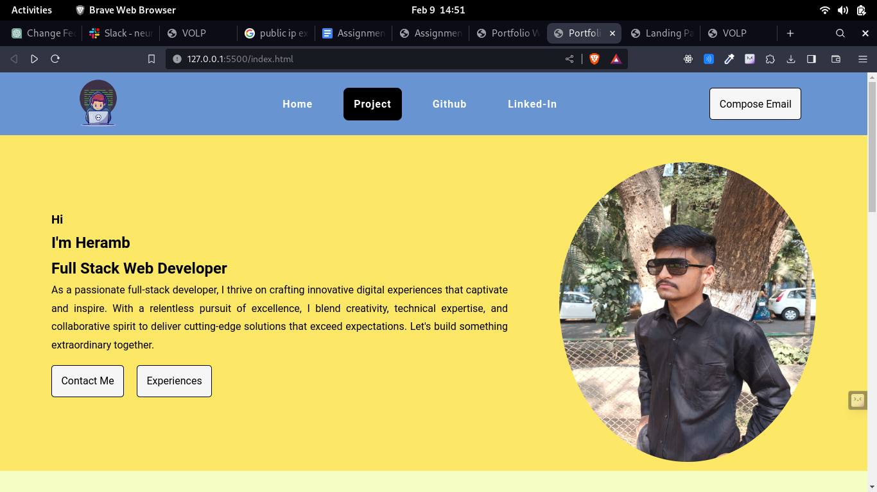

**HOME PAGE WITH HOVER EFFECT IN NAVBAR AND WORKING COMPOSE EMAIL BUTTON WHICH WILL REDIRECT TO SPECIFIED EMAIL APP**

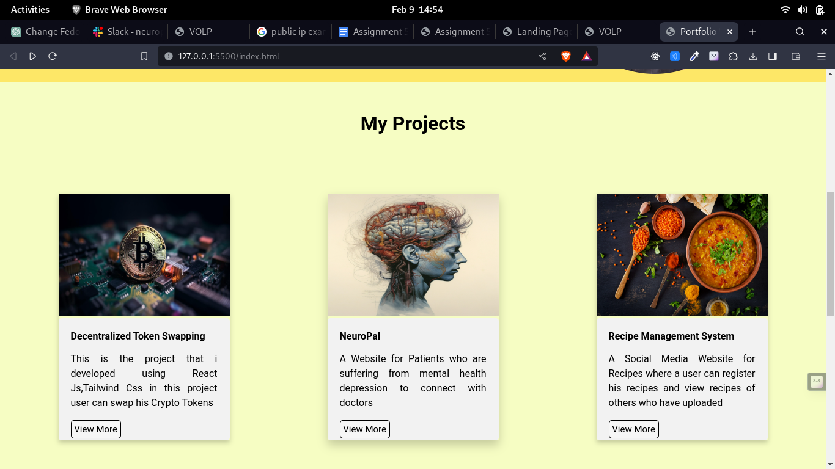

**PROJECT SECTION WITH WORKING BUTTON WHICH WILL REDIRECT TO SPECIFIED LINKS**

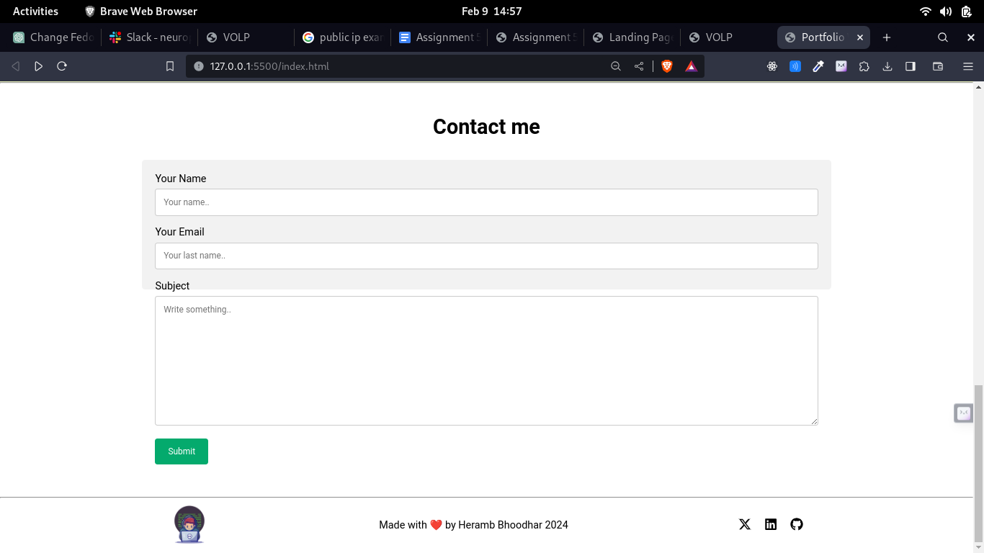

**CONTACT SECTION WITH FOOTER**